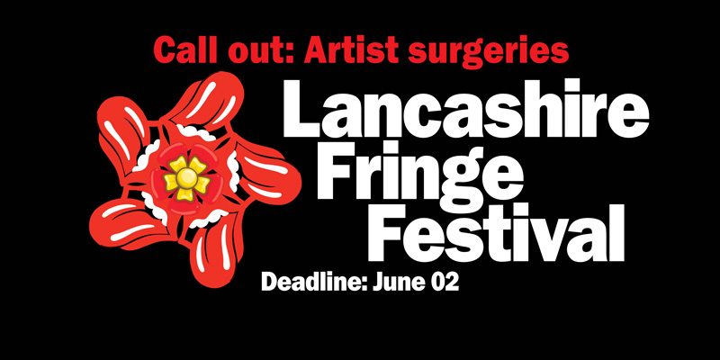LANCASHIRE FRINGE FESTIVAL 2024
ARTIST SURGERIES
For Preston-based performers and artists

LANCASHIRE FRINGE FESTIVAL will take place between late September and October 2024 in Preston. As part of our work we want to support and encourage Preston-based creatives to apply for jobs, commissions and funding – and generally develop their artistic practice.

Through Lancashire Fringe Festival and our wider work as Enjoy the Show we have seen how little support there is for Preston-based artists and performers.

So, as part of this year’s Lancashire Fringe Festival, we have allocated time and resources to offer several Preston-based creatives a one-to-one surgeries. While there is no strict format to these surgeries, we anticipate at have two face-to-face meetings, plus follow up emails and support.

These surgeries are not restricted to theatre performers – we are happy to receive applications from artists and creatives from any art form.

If you have an exciting idea for your practice and don’t know how to take the next steps or if you would like advice and support on writing a funding bid for a project, fill in the short form below and rename this word document with your surname_firstname.

Applications will be assessed on clarity of why you want an artist surgery and evidence of artistic ability.

For any questions you can email Garry Cook at gazcook@googlemail.com

Closing date for submissions is 11.59pm, Sunday, June 02, 2024.
Email your submissions to gazcook@googlemail.com

What we need

Name:

Email address:

What is your artistic practice:

Brief details about why you would like a one-to-one artist surgery:

Link(s) to examples of your work (text/images/video – CV can be sent separately):

Demonstrate your link to Preston:

